**COURSE: Drone Tech. II Honors *Teacher: Mrs. N. Penn* Email: pennn@gcsnc.com**

**Western Guilford High School *Phone: School (336) 316-5800 / Google Voice (336) 265-6496***

**Grading Scale**:

Process 60%

(ex: HW/Classwork/Skill Demo)

Product 40%

(ex: Projects, Assessments)

Late Policy: After 1st week, pts will be deducted in increments daily/weekly

**Tuesday Tutoring- 4:30 to 5:30 by appt.

*Assessments are usually administered on Thursdays but subject to change. Quizzes maybe unannounced.

**Course Info:** Welcome to **Drone Technology II** review to prepare for credential licensing assessment & complete Internship/Advance Certifications

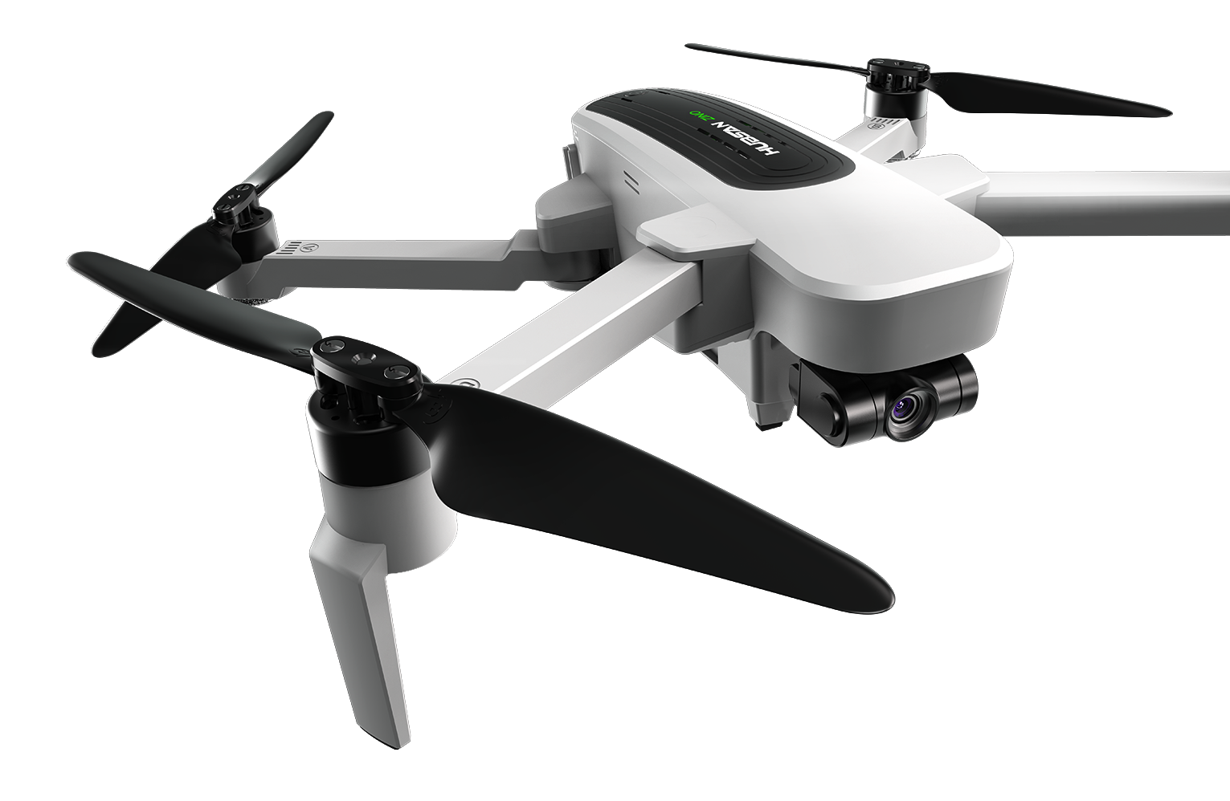

**Course Objectives**: To equip students with advanced drone knowledge to be successful as self-employed or industry hired commercial drone pilots. This is accomplished thru add’l credentialing attainment and competitions to practice drone business mgmt..

**Course Info/ Description:**

This course is designed to provide students, who have or will attain their FAA CFR 14 Part 107 (The Small UAS Rule), officially known as "Part 107 Remote Pilot Certificate" the knowledge and skills needed to be a commercial pilot in the Drone Industry. Entrepreneurship, Fleet management, and Drone software are included in this course. Students will fly a variety of mission types to include Construction, Agriculture, Public Safety, Power and Energy, and Cinematography. English language arts are reinforced.

m

**Course Resource/Materials:**

***Provided***: Cost for Credentials, Drones, Safety Equipment & more*

***Materials Needed****:* (see below)

* Notebook –(bring back)

**\*Credentials: (No Cost)**

*LASPEN

*ESRI Drone to Map

**Fees:**

($15) for AMA flight membership /insurance

$20 for SKIll USA CTSO Membership

$70 Skills USA Competition - TBD

Course Standards:

**1.00 Understand entrepreneurship in the drone industry.**

**2.00 Apply procedures used in drone fleet operations.**

**3.00 Apply procedures used in drone simulated environment.**

**4.00 Apply procedures used in the drone industry. (LASPEN certification)**

**5.00 Apply procedures used in drone mapping.**

**Assessment of Learning**: Students will be evaluated via FAA Exam, projects/flight missions, quizzes, notebook check, safety practice, workplace skills. Advance certs.

**\*Electronic Communication**

*“Out of sight, Out of sound”* **No** phones/No ear buds/No electronic devices should be out during instruction or teaming unless by permission of teacher.

**Academic Policies and Procedures:**

Students will be given opportunities for tutoring and additional support as well as enrichment to support comprehension and application of instruction.

If failing class at end of quarter **students must** set up a conference time to review means for developing routine to ensure prepared to test and attain license.

**Major Exam:** The FAA ***Unmanned Aircraft General - Small (UAG)***

Student must demonstrate a level of proficiency of 70% on online/written exam to pass administered at a testing ctr at PTI.

** 85%or higher on three (3) practice exams is recommended before taking test to ensure best performance. 75% is expected.

**Expectations\***: To assist in bringing life to our goals the following guidelines for class behaviors are expected that we call “REP CPR” in our BeeHive Drone Rm…DAILY….*Be* ***R****espectful, Be* ***E****xcellent, Be* ***P****repared,*

*Be* ***C****ompliant, Be* ***P****repared, and Be* ***R****esponsible*

*Examples: Be On-Time, Participate, Teaming/Taking Turns, Staying Engaged,, Responsive to Constructive Criticism, Cordial in Conversation, Practice Safety at all times,…..*

**Rewards:** Extended Flight Time, Student of the Month Recognition, Incentives, Selection/Recommendations for Special Field Trips

**Consequences:** Warning, Isolation, After-School Detention, Call Home, Referral (Note: order may vary based on incident)

***Next:*** *Sign & Return* Attached Pg. by Sept 10th